Ideation Phase
Define the Problem Statements
Date | 31 January 2025
Team ID
Project Name | AI Based Exam Anxiety Detector
Maximum Marks | 2 Marks

Customer Problem Statement Template:
Students preparing for exams often experience anxiety but lack an accessible tool to identify and understand their emotional state, while educational institutions need an intelligent system to detect and monitor exam-related stress in order to provide timely support and improve student well-being.

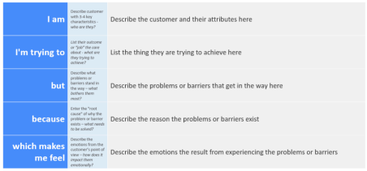Reference: https://miro.com/templates/customer-problem-statement/
Example:
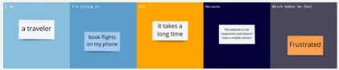
Problem  Statement (PS) | I am  (Customer) | I’m trying to | But | Because | Which makes me feel
PS-1 | I am  a student preparing for exams | manage my stress and understand my emotional state before examinations | I do not have a simple way to identify whether my feelings are normal stress or serious exam anxiety | most existing methods rely on surveys or counseling sessions that are not available in real time | overwhelmed, nervous, and unsupported during important academic periods.
PS-2 | I am  an educational institution or academic counselor | identify students who are experiencing high exam-related anxiety so that timely support can be provided | it is difficult to monitor the emotional state of a large number of students using traditional methods | manual observation and feedback collection are slow and often fail to detect hidden stress | concerned about student well-being and unable to intervene early to reduce exam pressure.

